**Read carefully before you begin**

* For question 1 and 2: you only need to answer them if you have not provided answers in your application screening questions.
* For questions 3 to 8:
  + Pick 4 questions that you are most comfortable with to answer. And state your assumptions if anything is not clear.
  + If you have used any large language models (e.g. ChatGPT) to assist with your answers, declare it with a note at the end of the answer, along with the LLM model and all the prompts you used to get to the final answer.

**Question 1:** Have you written any Python code in your personal GitHub repository that you can share with a link?

**Answer:** <https://github.com/guangliangyang/pingpong-foul>

**Question 2:** How many years of commercial experience do you have in Snowflake and Python programming respectively?

**Answer:** Snowflake <1 month, Python > 5 Years

**Question 3**

Design and create a logical data model using the star schema methodology to store the electricity outage dataset below in Snowflake. Define primary/foreign/surrogate keys for each table and the data types for each column. Note that the number of customers on a transformer may change over time, and the model and table structure must support preserving these changes during the ETL process.

| **Outage ID** | **Outage Suburb** | **Transformer Code** | **# of Customers on Transformer** | **Outage Start Time** | **Outage End Time** | **Outage Status** | **Outage Duration in Minutes** |
| --- | --- | --- | --- | --- | --- | --- | --- |
| 12345 | Ponsonby | KCN ME01 | 1,200 | 25/06/2024 8:00 | 25/06/2024 9:00 | Closed | 60 |
| 12346 | Albany | KNN CEP1 | 500 | 25/07/2024 8:30 | 25/07/2024 10:30 | Closed | 120 |
| 12347 | Remuera | REMU MK01 | 30 | 27/08/2024 8:30 | 27/08/2024 10:30 | Closed | 120 |
| 12347 | Remuera | REMU MK09 | 2,000 | 27/08/2024 8:30 | 27/08/2024 9:00 | Closed | 30 |
| 12347 | Remuera | REMU MU78 | 100 | 27/08/2024 8:30 | 27/08/2024 8:50 | Closed | 20 |
| 13349 | Ponsonby | KCN ME01 | 13 | 31/08/2024 20:00 |  | Open | 300 |
| 13350 | Takapuna | KNN CXP8 | 150 | 31/08/2024 22:10 |  | Open | 430 |

**Answer:**

1. **Assumptions**

* The model must support 3+ years of historical outage analysis with geographic (region/city/suburb) and temporal (year-to-hour) aggregations while tracking quarterly transformer customer count changes.
* Data characteristics include 50-500 daily outages across 5K-50K transformers, with strict quality rules for outage IDs, transformer codes, and sub-2-hour timestamp updates.
* Performance targets require 95% of queries under 5 seconds for 50+ concurrent users, accommodating ≤50% annual data growth over 3 years.
* Transformer Code is a stable business identifier for transformers, The start time of power outages is always accurately recorded.

1. **LLM**

Claude Sonnet 4

Prompt: question and assumptions

1. **Design** 
   1. **Fact Table**

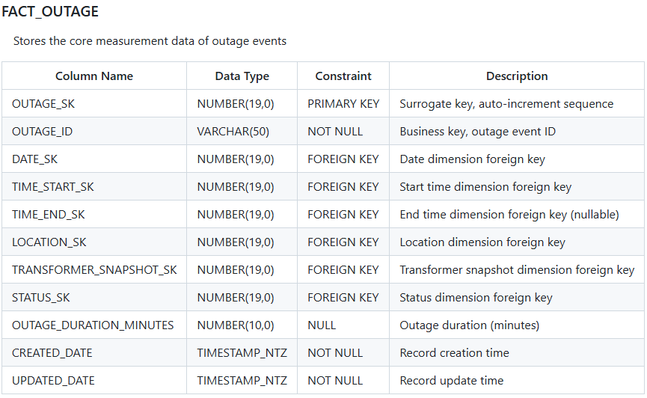

* 1. **Dimension Table**

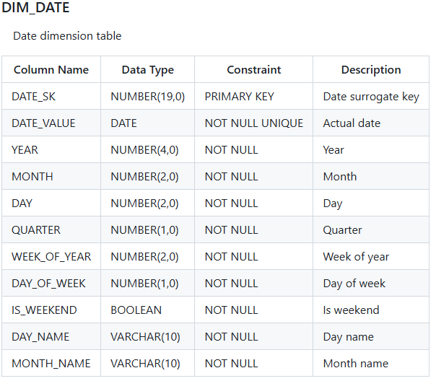

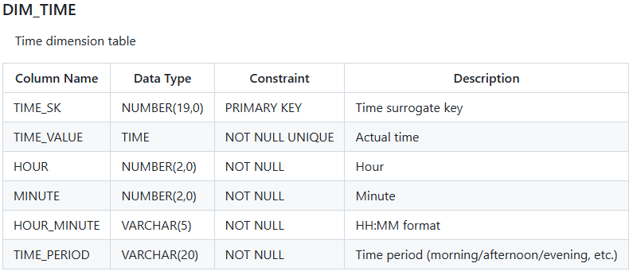

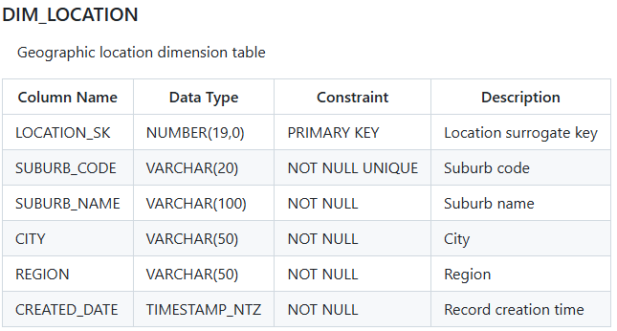

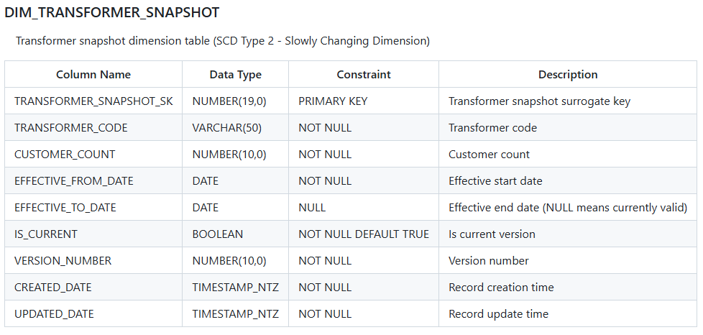

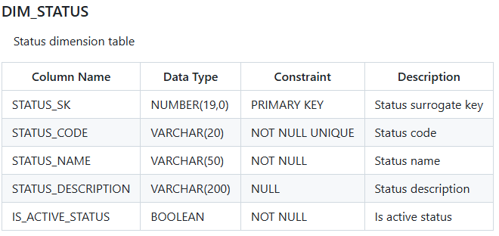

* 1. **Index Design**

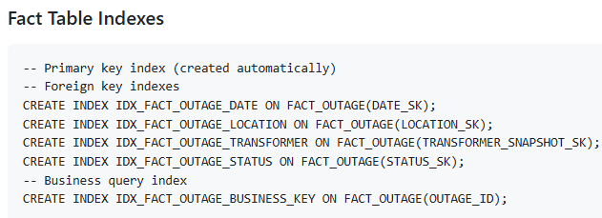

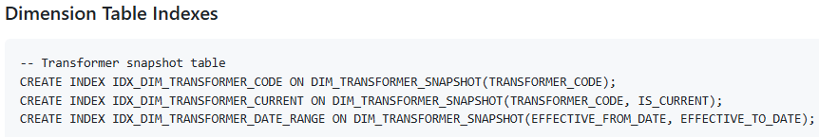

**Question 4**

On 1 Sep 2024, the daily ETL receives the following outage record from the Outage Management System (OMS):

| **Outage ID** | **Outage Suburb** | **Transformer Code** | **# of Customers on Transformer** | **Outage Start Time** | **Outage End Time** | **Outage Status** | **Outage Duration in Minutes** |
| --- | --- | --- | --- | --- | --- | --- | --- |
| 14508 | Milford | KNN CXP9 | 1,000 | 01/09/2024 8:00 |  | Open | 60 |

However, the TRANS system—your source for transformer attributes (size, install date, etc.)—is offline and is not expected back until 6 Sep 2024. Describe an ETL strategy that:

* preserves referential integrity between the fact and transformer dimension tables,
* allows outage reporting to continue between 1 Sep and 6 Sep, and
* back-fills the correct transformer attributes once TRANS is online.

**Answer:**

1. **Assumptions**
   * Sufficient ETL window, there is enough time for backfill processing.
2. **LLM**

Claude Sonnet 4

Prompt: question and “Does the Snowflake system have a mature solution for this situation?”

1. **Solution**

**## 2. Data Model Design**

**### 2.1 Extend Transformer Dimension Table**

```sql

-- Extend the existing dimension table to support data source tracking

ALTER TABLE DIM_TRANSFORMER_SNAPSHOT ADD COLUMN (

DATA_SOURCE VARCHAR(50) DEFAULT 'TRANS',

IS_PLACEHOLDER BOOLEAN DEFAULT FALSE,

NEEDS_BACKFILL BOOLEAN DEFAULT FALSE,

TRANSFORMER_SIZE_KVA NUMBER(10,2) NULL,

INSTALL_DATE DATE NULL,

MANUFACTURER VARCHAR(100) NULL,

MODEL VARCHAR(100) NULL,

VOLTAGE_RATING VARCHAR(20) NULL

);

-- Create index to optimize query performance

CREATE INDEX IDX_DIM_TRANSFORMER_SOURCE

ON DIM_TRANSFORMER_SNAPSHOT(DATA_SOURCE, IS_PLACEHOLDER);

```

**### 2.2 Staging Table Design**

```sql

-- Raw data staging table

CREATE TABLE STG_PENDING_OUTAGES (

STAGING_ID NUMBER(19,0) IDENTITY PRIMARY KEY,

OUTAGE_ID VARCHAR(50) NOT NULL,

OUTAGE_SUBURB VARCHAR(100),

TRANSFORMER_CODE VARCHAR(50),

CUSTOMER_COUNT NUMBER(10,0),

OUTAGE_START_TIME TIMESTAMP_NTZ,

OUTAGE_END_TIME TIMESTAMP_NTZ,

OUTAGE_STATUS VARCHAR(20),

OUTAGE_DURATION_MINUTES NUMBER(10,0),

RECEIVED_DATE TIMESTAMP_NTZ DEFAULT CURRENT_TIMESTAMP,

PROCESSED_FLAG BOOLEAN DEFAULT FALSE,

BACKFILL_REQUIRED BOOLEAN DEFAULT FALSE

) DATA_RETENTION_TIME_IN_DAYS = 7;

-- TRANS system attribute staging table

CREATE TABLE STG_TRANSFORMER_ATTRIBUTES (

TRANSFORMER_CODE VARCHAR(50) PRIMARY KEY,

TRANSFORMER_SIZE_KVA NUMBER(10,2),

INSTALL_DATE DATE,

MANUFACTURER VARCHAR(100),

MODEL VARCHAR(100),

VOLTAGE_RATING VARCHAR(20),

LOCATION_DETAILS VARCHAR(200),

ACTUAL_CUSTOMER_COUNT NUMBER(10,0),

LAST_MAINTENANCE_DATE DATE,

LOADED_DATE TIMESTAMP_NTZ DEFAULT CURRENT_TIMESTAMP

) DATA_RETENTION_TIME_IN_DAYS = 30;

```

**## 3. Phase 1: Temporary Processing Strategy (1-6 Sep)**

**### 3.1 Data Protection and Backup**

```sql

-- Create a backup at the time point before the system goes offline

CREATE TABLE DIM_TRANSFORMER_SNAPSHOT_BACKUP

CLONE DIM_TRANSFORMER_SNAPSHOT

AT(TIMESTAMP => '2024-08-31 23:59:59');

-- Set appropriate retention period

ALTER TABLE DIM_TRANSFORMER_SNAPSHOT

SET DATA_RETENTION_TIME_IN_DAYS = 7;

```

**### 3.2 Temporary Data Processing Workflow**

```sql

-- Stored procedure to check if transformer exists

CREATE OR REPLACE PROCEDURE check_and_create_transformer(

transformer_code VARCHAR(50),

customer_count NUMBER(10,0),

effective_date DATE

)

RETURNS NUMBER

LANGUAGE SQL

AS

$$

DECLARE

transformer_exists NUMBER DEFAULT 0;

new_transformer_sk NUMBER;

BEGIN

-- Check if transformer already exists

SELECT COUNT(*) INTO transformer_exists

FROM DIM_TRANSFORMER_SNAPSHOT

WHERE TRANSFORMER_CODE = transformer_code

AND IS_CURRENT = TRUE;

IF (transformer_exists = 0) THEN

-- Create placeholder record

INSERT INTO DIM_TRANSFORMER_SNAPSHOT (

TRANSFORMER_CODE,

CUSTOMER_COUNT,

EFFECTIVE_FROM_DATE,

EFFECTIVE_TO_DATE,

IS_CURRENT,

VERSION_NUMBER,

IS_PLACEHOLDER,

DATA_SOURCE,

NEEDS_BACKFILL,

CREATED_DATE,

UPDATED_DATE

) VALUES (

transformer_code,

customer_count,

effective_date,

NULL,

TRUE,

1,

TRUE,

'OMS_TEMP',

TRUE,

CURRENT_TIMESTAMP,

CURRENT_TIMESTAMP

);

SELECT TRANSFORMER_SNAPSHOT_SK INTO new_transformer_sk

FROM DIM_TRANSFORMER_SNAPSHOT

WHERE TRANSFORMER_CODE = transformer_code

AND IS_CURRENT = TRUE;

RETURN new_transformer_sk;

ELSE

-- Return existing record SK

SELECT TRANSFORMER_SNAPSHOT_SK INTO new_transformer_sk

FROM DIM_TRANSFORMER_SNAPSHOT

WHERE TRANSFORMER_CODE = transformer_code

AND IS_CURRENT = TRUE;

RETURN new_transformer_sk;

END IF;

END;

$$;

```

**### 3.3 Process Outage Records**

```sql

-- Main ETL process for new outage records

CREATE OR REPLACE PROCEDURE process_outage_record()

RETURNS STRING

LANGUAGE SQL

AS

$$

DECLARE

transformer_sk NUMBER;

BEGIN

-- Stage raw data

INSERT INTO STG_PENDING_OUTAGES (

OUTAGE_ID, OUTAGE_SUBURB, TRANSFORMER_CODE, CUSTOMER_COUNT,

OUTAGE_START_TIME, OUTAGE_END_TIME, OUTAGE_STATUS,

OUTAGE_DURATION_MINUTES, BACKFILL_REQUIRED

) VALUES (

'14508', 'Milford', 'KNN CXP9', 1000,

'2024-09-01 08:00:00', NULL, 'Open', 60, TRUE

);

-- Check and create transformer record

CALL check_and_create_transformer('KNN CXP9', 1000, '2024-09-01')

INTO transformer_sk;

-- Process fact table record

INSERT INTO FACT_OUTAGE (

OUTAGE_ID, DATE_SK, TIME_START_SK, TIME_END_SK,

LOCATION_SK, TRANSFORMER_SNAPSHOT_SK, STATUS_SK,

OUTAGE_DURATION_MINUTES, CREATED_DATE, UPDATED_DATE

)

SELECT

'14508',

d.DATE_SK,

ts.TIME_SK,

NULL,

l.LOCATION_SK,

transformer_sk,

st.STATUS_SK,

60,

CURRENT_TIMESTAMP,

CURRENT_TIMESTAMP

FROM DIM_DATE d

CROSS JOIN DIM_TIME ts

CROSS JOIN DIM_LOCATION l

CROSS JOIN DIM_STATUS st

WHERE d.DATE_VALUE = '2024-09-01'

AND ts.TIME_VALUE = '08:00:00'

AND l.SUBURB_NAME = 'Milford'

AND st.STATUS_CODE = 'Open';

RETURN 'Outage record processed successfully with temporary transformer data';

END;

$$;

```

**## 4. Monitoring Using Native Snowflake Features**

**### 4.1 Create Change Tracking Streams**

```sql

-- Create change tracking stream for transformer dimension

CREATE STREAM dim_transformer_changes_stream

ON TABLE DIM_TRANSFORMER_SNAPSHOT

COMMENT = 'Track changes to transformer dimension for TRANS backfill';

-- Create change tracking stream for fact table (for audit)

CREATE STREAM fact_outage_changes_stream

ON TABLE FACT_OUTAGE

COMMENT = 'Track outage fact table changes during TRANS outage';

```

**### 4.2 Dynamic Table for Automated Monitoring**

```sql

-- Create monitoring view

CREATE OR REPLACE DYNAMIC TABLE transformer_status_monitor

TARGET_LAG = '5 minutes'

WAREHOUSE = ETL_SMALL_WH

AS

SELECT

COUNT(*) as TOTAL_TRANSFORMERS,

COUNT(CASE WHEN IS_PLACEHOLDER = TRUE THEN 1 END) as PLACEHOLDER_COUNT,

COUNT(CASE WHEN NEEDS_BACKFILL = TRUE THEN 1 END) as PENDING_BACKFILL,

MIN(CASE WHEN IS_PLACEHOLDER = TRUE THEN CREATED_DATE END) as OLDEST_PLACEHOLDER,

CURRENT_TIMESTAMP as LAST_UPDATED

FROM DIM_TRANSFORMER_SNAPSHOT

WHERE IS_CURRENT = TRUE;

```

**## 5. Phase 2: Automated Backfill Strategy (After 6 Sep)**

**### 5.1 TRANS System Recovery Detection**

```sql

-- Create system availability detection task

CREATE OR REPLACE TASK check_trans_availability

WAREHOUSE = ETL_SMALL_WH

SCHEDULE = '15 MINUTE'

AS

DECLARE

trans_available BOOLEAN DEFAULT FALSE;

pending_count NUMBER DEFAULT 0;

BEGIN

-- Simulate TRANS system health check

-- In actual implementation, this would check TRANS system health

-- Check for new transformer attribute data

SELECT COUNT(*) > 0 INTO trans_available

FROM STG_TRANSFORMER_ATTRIBUTES

WHERE LOADED_DATE >= DATEADD(hour, -1, CURRENT_TIMESTAMP);

-- Check for pending backfill records

SELECT COUNT(*) INTO pending_count

FROM DIM_TRANSFORMER_SNAPSHOT

WHERE NEEDS_BACKFILL = TRUE;

IF (trans_available AND pending_count > 0) THEN

-- Trigger backfill process

CALL execute_backfill_process();

END IF;

END;

-- Start the task

ALTER TASK check_trans_availability RESUME;

```

**### 5.2 Intelligent Backfill Processing**

```sql

CREATE OR REPLACE PROCEDURE execute_backfill_process()

RETURNS STRING

LANGUAGE SQL

AS

$$

DECLARE

processed_count NUMBER DEFAULT 0;

error_count NUMBER DEFAULT 0;

result_message STRING;

BEGIN

-- Handle cases where customer count matches

UPDATE DIM_TRANSFORMER_SNAPSHOT ts

SET

IS_PLACEHOLDER = FALSE,

DATA_SOURCE = 'TRANS',

NEEDS_BACKFILL = FALSE,

TRANSFORMER_SIZE_KVA = ta.TRANSFORMER_SIZE_KVA,

INSTALL_DATE = ta.INSTALL_DATE,

MANUFACTURER = ta.MANUFACTURER,

MODEL = ta.MODEL,

VOLTAGE_RATING = ta.VOLTAGE_RATING,

UPDATED_DATE = CURRENT_TIMESTAMP

FROM STG_TRANSFORMER_ATTRIBUTES ta

WHERE ts.TRANSFORMER_CODE = ta.TRANSFORMER_CODE

AND ts.IS_PLACEHOLDER = TRUE

AND ts.CUSTOMER_COUNT = ta.ACTUAL_CUSTOMER_COUNT;

processed_count := SQLROWCOUNT;

-- Handle cases where customer count does not match (SCD Type 2)

-- 1. Close old record

UPDATE DIM_TRANSFORMER_SNAPSHOT ts

SET

EFFECTIVE_TO_DATE = CURRENT_DATE - 1,

IS_CURRENT = FALSE,

UPDATED_DATE = CURRENT_TIMESTAMP

FROM STG_TRANSFORMER_ATTRIBUTES ta

WHERE ts.TRANSFORMER_CODE = ta.TRANSFORMER_CODE

AND ts.IS_PLACEHOLDER = TRUE

AND ts.CUSTOMER_COUNT != ta.ACTUAL_CUSTOMER_COUNT;

-- 2. Create new accurate record

INSERT INTO DIM_TRANSFORMER_SNAPSHOT (

TRANSFORMER_CODE, CUSTOMER_COUNT, EFFECTIVE_FROM_DATE,

EFFECTIVE_TO_DATE, IS_CURRENT, VERSION_NUMBER,

IS_PLACEHOLDER, DATA_SOURCE, NEEDS_BACKFILL,

TRANSFORMER_SIZE_KVA, INSTALL_DATE, MANUFACTURER,

MODEL, VOLTAGE_RATING, CREATED_DATE, UPDATED_DATE

)

SELECT

ta.TRANSFORMER_CODE,

ta.ACTUAL_CUSTOMER_COUNT,

CURRENT_DATE,

NULL,

TRUE,

ts.VERSION_NUMBER + 1,

FALSE,

'TRANS',

FALSE,

ta.TRANSFORMER_SIZE_KVA,

ta.INSTALL_DATE,

ta.MANUFACTURER,

ta.MODEL,

ta.VOLTAGE_RATING,

CURRENT_TIMESTAMP,

CURRENT_TIMESTAMP

FROM STG_TRANSFORMER_ATTRIBUTES ta

JOIN DIM_TRANSFORMER_SNAPSHOT ts

ON ta.TRANSFORMER_CODE = ts.TRANSFORMER_CODE

WHERE ts.IS_PLACEHOLDER = TRUE

AND ts.CUSTOMER_COUNT != ta.ACTUAL_CUSTOMER_COUNT;

-- Update staging table processing status

UPDATE STG_PENDING_OUTAGES

SET PROCESSED_FLAG = TRUE,

BACKFILL_REQUIRED = FALSE

WHERE TRANSFORMER_CODE IN (

SELECT TRANSFORMER_CODE

FROM DIM_TRANSFORMER_SNAPSHOT

WHERE DATA_SOURCE = 'TRANS'

);

result_message := 'Backfill completed. Processed: ' || processed_count || ' records';

-- Log processing result

INSERT INTO ETL_PROCESS_LOG (

PROCESS_NAME, STATUS, MESSAGE, PROCESSED_COUNT,

ERROR_COUNT, CREATED_DATE

) VALUES (

'TRANS_BACKFILL', 'SUCCESS', result_message,

processed_count, error_count, CURRENT_TIMESTAMP

);

RETURN result_message;

EXCEPTION

WHEN OTHER THEN

INSERT INTO ETL_PROCESS_LOG (

PROCESS_NAME, STATUS, MESSAGE, ERROR_DETAILS, CREATED_DATE

) VALUES (

'TRANS_BACKFILL', 'ERROR', 'Backfill process failed',

SQLERRM, CURRENT_TIMESTAMP

);

RETURN 'Backfill failed: ' || SQLERRM;

END;

$$;

```

**## 6. Business Continuity Assurance**

**### 6.1 Reporting View**

```sql

-- Provide a transparent reporting view for business users

CREATE OR REPLACE SECURE VIEW V_OUTAGE_REPORTING AS

SELECT

f.OUTAGE_ID,

l.SUBURB_NAME,

ts.TRANSFORMER_CODE,

ts.CUSTOMER_COUNT,

CASE

WHEN ts.IS_PLACEHOLDER = TRUE

THEN ts.CUSTOMER_COUNT || ' (Temporary Estimate)'

ELSE ts.CUSTOMER_COUNT || ''

END as CUSTOMER_COUNT_DISPLAY,

d.DATE_VALUE as OUTAGE_DATE,

t1.TIME_VALUE as START_TIME,

t2.TIME_VALUE as END_TIME,

s.STATUS_NAME,

f.OUTAGE_DURATION_MINUTES,

ts.DATA_SOURCE,

CASE

WHEN ts.IS_PLACEHOLDER = TRUE THEN 'Y'

ELSE 'N'

END as IS_ESTIMATED_DATA,

ts.TRANSFORMER_SIZE_KVA,

ts.MANUFACTURER,

ts.INSTALL_DATE

FROM FACT_OUTAGE f

JOIN DIM_DATE d ON f.DATE_SK = d.DATE_SK

JOIN DIM_TIME t1 ON f.TIME_START_SK = t1.TIME_SK

LEFT JOIN DIM_TIME t2 ON f.TIME_END_SK = t2.TIME_SK

JOIN DIM_LOCATION l ON f.LOCATION_SK = l.LOCATION_SK

JOIN DIM_TRANSFORMER_SNAPSHOT ts ON f.TRANSFORMER_SNAPSHOT_SK = ts.TRANSFORMER_SNAPSHOT_SK

JOIN DIM_STATUS s ON f.STATUS_SK = s.STATUS_SK;

```

**### 6.2 Data Quality Monitoring**

```sql

-- Data quality monitoring dashboard

CREATE OR REPLACE VIEW V_DATA_QUALITY_DASHBOARD AS

SELECT

'Placeholder Records' as METRIC_NAME,

COUNT(*) as METRIC_VALUE,

'Count' as METRIC_TYPE,

CURRENT_TIMESTAMP as LAST_UPDATED

FROM DIM_TRANSFORMER_SNAPSHOT

WHERE IS_PLACEHOLDER = TRUE AND IS_CURRENT = TRUE

UNION ALL

SELECT

'Pending Backfill Records' as METRIC_NAME,

COUNT(*) as METRIC_VALUE,

'Count' as METRIC_TYPE,

CURRENT_TIMESTAMP as LAST_UPDATED

FROM DIM_TRANSFORMER_SNAPSHOT

WHERE NEEDS_BACKFILL = TRUE

UNION ALL

SELECT

'Unprocessed Staging Records' as METRIC_NAME,

COUNT(*) as METRIC_VALUE,

'Count' as METRIC_TYPE,

CURRENT_TIMESTAMP as LAST_UPDATED

FROM STG_PENDING_OUTAGES

WHERE PROCESSED_FLAG = FALSE

UNION ALL

SELECT

'Oldest Placeholder Age (Hours)' as METRIC_NAME,

DATEDIFF(hour, MIN(CREATED_DATE), CURRENT_TIMESTAMP) as METRIC_VALUE,

'Hours' as METRIC_TYPE,

CURRENT_TIMESTAMP as LAST_UPDATED

FROM DIM_TRANSFORMER_SNAPSHOT

WHERE IS_PLACEHOLDER = TRUE AND IS_CURRENT = TRUE;

```

**## 7. Data Validation and Exception Handling**

**### 7.1 Automated Data Validation**

```sql

-- Data variance analysis view

CREATE OR REPLACE VIEW V_BACKFILL_ANALYSIS AS

SELECT

ts.TRANSFORMER_CODE,

ts.CUSTOMER_COUNT as OMS_COUNT,

ta.ACTUAL_CUSTOMER_COUNT as TRANS_COUNT,

ABS(ts.CUSTOMER_COUNT - ta.ACTUAL_CUSTOMER_COUNT) as DIFFERENCE,

ROUND(ABS(ts.CUSTOMER_COUNT - ta.ACTUAL_CUSTOMER_COUNT) * 100.0 /

NULLIF(ta.ACTUAL_CUSTOMER_COUNT, 0), 2) as DIFFERENCE_PERCENT,

CASE

WHEN ABS(ts.CUSTOMER_COUNT - ta.ACTUAL_CUSTOMER_COUNT) = 0

THEN 'EXACT_MATCH'

WHEN ABS(ts.CUSTOMER_COUNT - ta.ACTUAL_CUSTOMER_COUNT) <= 10

THEN 'MINOR_VARIANCE'

WHEN ABS(ts.CUSTOMER_COUNT - ta.ACTUAL_CUSTOMER_COUNT) <= 100

THEN 'MODERATE_VARIANCE'

ELSE 'HIGH_VARIANCE'

END as VARIANCE_CATEGORY,

ts.CREATED_DATE as PLACEHOLDER_CREATED,

ta.LOADED_DATE as TRANS_DATA_LOADED

FROM DIM_TRANSFORMER_SNAPSHOT ts

JOIN STG_TRANSFORMER_ATTRIBUTES ta

ON ts.TRANSFORMER_CODE = ta.TRANSFORMER_CODE

WHERE ts.IS_PLACEHOLDER = TRUE;

```

**### 7.2 Exception Handling and Alerts**

```sql

-- Exception record table

CREATE TABLE ETL_EXCEPTIONS (

EXCEPTION_ID NUMBER(19,0) IDENTITY PRIMARY KEY,

PROCESS_NAME VARCHAR(100),

TABLE_NAME VARCHAR(100),

RECORD_IDENTIFIER VARCHAR(200),

EXCEPTION_TYPE VARCHAR(50),

EXCEPTION_MESSAGE VARCHAR(1000),

SEVERITY_LEVEL VARCHAR(20),

CREATED_DATE TIMESTAMP_NTZ DEFAULT CURRENT_TIMESTAMP,

RESOLVED_DATE TIMESTAMP_NTZ,

RESOLUTION_NOTES VARCHAR(1000),

RESOLVED_BY VARCHAR(100)

);

-- Automated anomaly detection task

CREATE OR REPLACE TASK detect_data_anomalies

WAREHOUSE = ETL_SMALL_WH

SCHEDULE = '60 MINUTE'

AS

BEGIN

-- Detect high variance records

INSERT INTO ETL_EXCEPTIONS (

PROCESS_NAME, TABLE_NAME, RECORD_IDENTIFIER,

EXCEPTION_TYPE, EXCEPTION_MESSAGE, SEVERITY_LEVEL

)

SELECT

'BACKFILL_VALIDATION',

'DIM_TRANSFORMER_SNAPSHOT',

TRANSFORMER_CODE,

'HIGH_VARIANCE',

'Customer count variance > 100: OMS=' || OMS_COUNT ||

', TRANS=' || TRANS_COUNT || ', Diff=' || DIFFERENCE,

'HIGH'

FROM V_BACKFILL_ANALYSIS

WHERE VARIANCE_CATEGORY = 'HIGH_VARIANCE'

AND TRANSFORMER_CODE NOT IN (

SELECT RECORD_IDENTIFIER

FROM ETL_EXCEPTIONS

WHERE EXCEPTION_TYPE = 'HIGH_VARIANCE'

AND RESOLVED_DATE IS NULL

);

-- Detect long-running placeholders

INSERT INTO ETL_EXCEPTIONS (

PROCESS_NAME, TABLE_NAME, RECORD_IDENTIFIER,

EXCEPTION_TYPE, EXCEPTION_MESSAGE, SEVERITY_LEVEL

)

SELECT

'PLACEHOLDER_MONITORING',

'DIM_TRANSFORMER_SNAPSHOT',

TRANSFORMER_CODE,

'LONG_RUNNING_PLACEHOLDER',

'Placeholder record exists for > 7 days: Created=' || CREATED_DATE,

'MEDIUM'

FROM DIM_TRANSFORMER_SNAPSHOT

WHERE IS_PLACEHOLDER = TRUE

AND CREATED_DATE < DATEADD(day, -7, CURRENT_TIMESTAMP)

AND TRANSFORMER_CODE NOT IN (

SELECT RECORD_IDENTIFIER

FROM ETL_EXCEPTIONS

WHERE EXCEPTION_TYPE = 'LONG_RUNNING_PLACEHOLDER'

AND RESOLVED_DATE IS NULL

);

END;

ALTER TASK detect_data_anomalies RESUME;

```

**## 8. Recovery and Rollback Mechanisms**

**### 8.1 Recovery Using Time Travel**

```sql

-- Data recovery stored procedure

CREATE OR REPLACE PROCEDURE emergency_data_recovery(recovery_timestamp TIMESTAMP_NTZ)

RETURNS STRING

LANGUAGE SQL

AS

$$

DECLARE

backup_table_name STRING;

BEGIN

-- Generate unique backup table name

backup_table_name := 'DIM_TRANSFORMER_SNAPSHOT_RECOVERY_' ||

TO_VARCHAR(CURRENT_TIMESTAMP, 'YYYYMMDDHH24MISS');

-- Create current state backup

EXECUTE IMMEDIATE 'CREATE TABLE ' || backup_table_name ||

' CLONE DIM_TRANSFORMER_SNAPSHOT';

-- Restore to specified time point

EXECUTE IMMEDIATE 'CREATE OR REPLACE TABLE DIM_TRANSFORMER_SNAPSHOT_TEMP CLONE DIM_TRANSFORMER_SNAPSHOT AT(TIMESTAMP => ''' || recovery_timestamp || ''')';

-- Replace current table

DROP TABLE DIM_TRANSFORMER_SNAPSHOT;

ALTER TABLE DIM_TRANSFORMER_SNAPSHOT_TEMP RENAME TO DIM_TRANSFORMER_SNAPSHOT;

-- Log recovery operation

INSERT INTO ETL_PROCESS_LOG (

PROCESS_NAME, STATUS, MESSAGE, CREATED_DATE

) VALUES (

'EMERGENCY_RECOVERY', 'SUCCESS',

'Data recovered to ' || recovery_timestamp || '. Backup: ' || backup_table_name,

CURRENT_TIMESTAMP

);

RETURN 'Recovery completed. Backup table: ' || backup_table_name;

EXCEPTION

WHEN OTHER THEN

RETURN 'Recovery failed: ' || SQLERRM;

END;

$$;

```

**### 8.2 Progressive Validation and Correction**

```sql

-- Progressive data correction process

CREATE OR REPLACE PROCEDURE progressive_data_correction()

RETURNS STRING

LANGUAGE SQL

AS

$$

DECLARE

correction_count NUMBER DEFAULT 0;

BEGIN

-- Correct small variances (<= 5%)

UPDATE DIM_TRANSFORMER_SNAPSHOT ts

SET

CUSTOMER_COUNT = ta.ACTUAL_CUSTOMER_COUNT,

UPDATED_DATE = CURRENT_TIMESTAMP

FROM STG_TRANSFORMER_ATTRIBUTES ta

WHERE ts.TRANSFORMER_CODE = ta.TRANSFORMER_CODE

AND ts.IS_PLACEHOLDER = TRUE

AND ABS(ts.CUSTOMER_COUNT - ta.ACTUAL_CUSTOMER_COUNT) * 100.0 /

NULLIF(ta.ACTUAL_CUSTOMER_COUNT, 0) <= 5;

correction_count := SQLROWCOUNT;

RETURN 'Progressive correction completed. ' || correction_count || ' records updated.';

END;

$$;

```

**## 9. Cost Optimization and Performance Tuning**

**### 9.1 Storage Optimization**

```sql

-- Set appropriate retention period

ALTER TABLE STG_PENDING_OUTAGES SET DATA_RETENTION_TIME_IN_DAYS = 7;

ALTER TABLE STG_TRANSFORMER_ATTRIBUTES SET DATA_RETENTION_TIME_IN_DAYS = 30;

-- Use transient tables for temporary calculations

CREATE TRANSIENT TABLE temp_calculation_results AS

SELECT /* Temporary calculation logic */;

```

**### 9.2 Warehouse Size Optimization**

```sql

-- Create warehouses of different sizes for different workloads

CREATE WAREHOUSE ETL_SMALL_WH WITH

WAREHOUSE_SIZE = 'XSMALL'

AUTO_SUSPEND = 60

AUTO_RESUME = TRUE

COMMENT = 'For routine ETL and monitoring tasks';

CREATE WAREHOUSE ETL_BACKFILL_WH WITH

WAREHOUSE_SIZE = 'MEDIUM'

AUTO_SUSPEND = 60

AUTO_RESUME = TRUE

COMMENT = 'For backfill and recovery operations';

```

**## 10. Deployment and Maintenance Guide**

**### 10.1 Deployment Checklist**

1. **\*\*Database Object Creation\*\***

- Extend dimension table structure

- Create staging tables

- Create all stored procedures and functions

2. **\*\*Monitoring Setup\*\***

- Create Streams

- Deploy Dynamic Tables

- Start Tasks

3. **\*\*Permission Configuration\*\***

- ETL role permissions

- Monitoring user access

- Business user view permissions

**### 10.2 Maintenance Operations**

```sql

-- Regularly clean up expired data

CREATE OR REPLACE TASK cleanup_expired_data

WAREHOUSE = ETL_SMALL_WH

SCHEDULE = 'USING CRON 0 2 * * SUN' -- Every Sunday at 2am

AS

BEGIN

-- Clean up expired staging data

DELETE FROM STG_PENDING_OUTAGES

WHERE PROCESSED_FLAG = TRUE

AND RECEIVED_DATE < DATEADD(day, -30, CURRENT_TIMESTAMP);

-- Clean up resolved exception records

DELETE FROM ETL_EXCEPTIONS

WHERE RESOLVED_DATE IS NOT NULL

AND RESOLVED_DATE < DATEADD(day, -90, CURRENT_TIMESTAMP);

-- Clean up expired logs

DELETE FROM ETL_PROCESS_LOG

WHERE CREATED_DATE < DATEADD(day, -180, CURRENT_TIMESTAMP);

END;

ALTER TASK cleanup_expired_data RESUME;

```

**Question 5**

Starting 1 Jul 2025, Microsoft Yammer (Viva Engage) will deprecate the OAuth2 based authentication, which means that only Azure Active Directory (AAD) token option is available. See below link for details of how Yammer AAD token authentication works.

<https://techcommunity.microsoft.com/blog/viva_engage_blog/yammer-api-with-aad-tokens-postman-collection/857923>

You are tasked with creating an automatic data pipeline that ingests messages daily from Yammer API v1. The data pipeline does not have an available web URL that you could use as callback URL when you pass parameters to get the AAD token. How would you design your data pipeline in Python or PowerShell to ingest data automatically without human intervention? Note code is not required but please explain:

* which OAuth2 grant type you would use and why
* the key values in header/body that you would pass to the authentication endpoint.
* how you would secure the credentials used in the authentication process.

**Answer:**

**Question 6**

You are working on an AI use case to classify causes of electricity outages by using the combined information from field notes from electricity technicians and the photos they have taken on the fault sites. Snowflake’s multimodal capability (AI_COMPLETE) only allows you to process up to 20 images at a time (see below the documentation), how would you design your AI solution in Snowflake if the field crews sometimes attach 30-40 photos per outage? Draw an architecture diagram (hand-drawn is acceptable) of the end-to-end solution. Provide enough details for a junior data & AI engineer to implement the solution.

<https://docs.snowflake.com/en/user-guide/snowflake-cortex/ai-images>

**Answer:**

1. **KeyPoints**
   * The system automatically partitions images into batches of ≤20 using SQL windowing functions, enabling parallel AI_COMPLETE processing across multiple batches simultaneously. Each batch generates classification probabilities for outage causes.
   * Probability Fusion Strategy，Individual batch probabilities are aggregated using confidence-weighted averaging, where high-confidence predictions receive greater influence in the final classification. The system calculates weighted probability distributions across all batches, ensuring robust predictions even when individual batches have varying quality or relevance.
2. **Workflow Design**

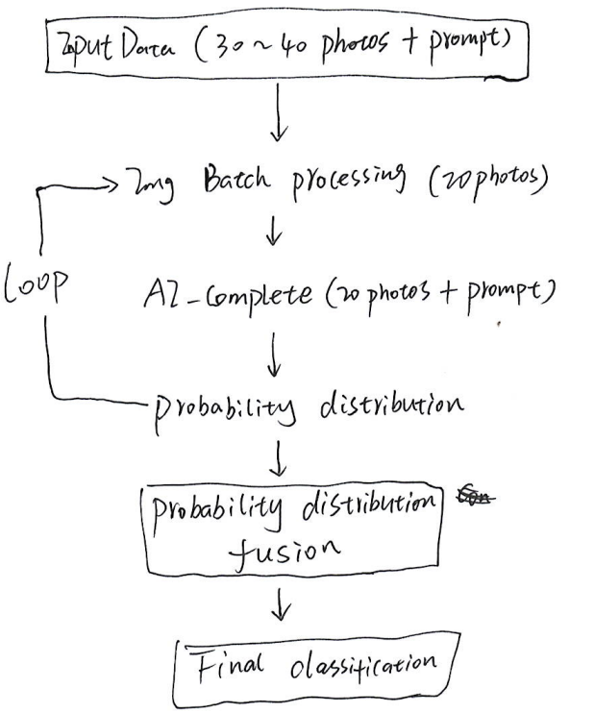

**Question 7**

Below is an example of first a few lines of an EIEP3 file, which is standard file format for half hourly electricity meter readings in NZ. Please write a SQL or Python script to load the file from SFTP into Snowflake without losing any useful information of the dataset.

*HDR,ICPHH,11,ENERGYCO,ENRG,DIST,09/06/2025,14:00:00,ID2025060914001,5,202505,E,I*

*DET,1234567890ABCD1,MTR123456789012,F,31/05/2025,1,20.35,5.12,,X,*

*DET,1234567890ABCD1,MTR123456789012,F,31/05/2025,2,19.87,4.98,,X,*

*DET,1234567890ABCD1,MTR123456789012,F,31/05/2025,3,21.10,5.34,,X,*

*DET,1234567890ABCD1,MTR123456789012,F,31/05/2025,4,22.45,5.68,,X,*

**Answer:**

1. **Assumptions**
   * Snowflake Enterprise Edition or higher (needs to support Tasks, Snowpipe, external functions)
   * Can be integrated with cloud storage, have appropriate IAM roles and permissions, and have a stable and secure network connection
   * Data format complies with EIEP3 standards
   * Data volume: file size is within a reasonable range (<100MB), and the frequency of file arrival does not exceed processing capacity
2. **LLM**

Claude Sonnet 4

Prompt: question and “ use snowflake native or advanced function to solve this problem if necessary”

1. **Solution**

**## 2. Snowflake Native Solution Architecture**

**### 2.1 Data Model Design**

**```sql**

**-- Create raw data staging table (retain all original information)**

**CREATE OR REPLACE TABLE STG_EIEP3_RAW (**

**FILE_NAME VARCHAR(500),**

**LINE_NUMBER NUMBER,**

**RECORD_TYPE VARCHAR(10),**

**RAW_LINE VARCHAR(5000),**

**LOAD_TIMESTAMP TIMESTAMP_NTZ DEFAULT CURRENT_TIMESTAMP,**

**PROCESS_STATUS VARCHAR(20) DEFAULT 'PENDING'**

**);**

**-- Create file header information table**

**CREATE OR REPLACE TABLE EIEP3_FILE_HEADERS (**

**FILE_HEADER_ID NUMBER(19,0) IDENTITY PRIMARY KEY,**

**FILE_NAME VARCHAR(500) NOT NULL,**

**RECORD_TYPE VARCHAR(10) DEFAULT 'HDR',**

**MESSAGE_TYPE VARCHAR(20),**

**VERSION_NUMBER VARCHAR(10),**

**SENDER_CODE VARCHAR(50),**

**SENDER_TYPE VARCHAR(10),**

**RECIPIENT_CODE VARCHAR(50),**

**CREATION_DATE DATE,**

**CREATION_TIME TIME,**

**MESSAGE_ID VARCHAR(100),**

**PRIORITY VARCHAR(10),**

**PERIOD VARCHAR(20),**

**TEST_INDICATOR VARCHAR(5),**

**DUPLICATE_INDICATOR VARCHAR(5),**

**LOAD_TIMESTAMP TIMESTAMP_NTZ DEFAULT CURRENT_TIMESTAMP**

**);**

**-- Create meter reading detail table**

**CREATE OR REPLACE TABLE EIEP3_METER_READINGS (**

**READING_ID NUMBER(19,0) IDENTITY PRIMARY KEY,**

**FILE_HEADER_ID NUMBER(19,0),**

**FILE_NAME VARCHAR(500),**

**ICP_IDENTIFIER VARCHAR(50) NOT NULL,**

**METER_SERIAL_NUMBER VARCHAR(50),**

**REGISTER_CODE VARCHAR(10),**

**READING_DATE DATE,**

**TRADING_PERIOD NUMBER(2,0),**

**CONSUMPTION_KWH NUMBER(12,3),**

**MAXIMUM_DEMAND_KW NUMBER(12,3),**

**RESERVED_FIELD VARCHAR(50),**

**QUALITY_FLAG VARCHAR(10),**

**LOAD_TIMESTAMP TIMESTAMP_NTZ DEFAULT CURRENT_TIMESTAMP,**

**FOREIGN KEY (FILE_HEADER_ID) REFERENCES EIEP3_FILE_HEADERS(FILE_HEADER_ID)**

**);**

**-- Create processing log table**

**CREATE OR REPLACE TABLE EIEP3_PROCESS_LOG (**

**LOG_ID NUMBER(19,0) IDENTITY PRIMARY KEY,**

**FILE_NAME VARCHAR(500),**

**PROCESS_STEP VARCHAR(100),**

**STATUS VARCHAR(20),**

**RECORDS_PROCESSED NUMBER,**

**ERROR_COUNT NUMBER,**

**ERROR_MESSAGE VARCHAR(1000),**

**PROCESSING_TIME_SECONDS NUMBER(10,2),**

**CREATED_TIMESTAMP TIMESTAMP_NTZ DEFAULT CURRENT_TIMESTAMP**

**);**

**```**

**### 2.2 SFTP Integration Setup**

**```sql**

**-- Create storage integration (for SFTP access)**

**CREATE OR REPLACE STORAGE INTEGRATION EIEP3_SFTP_INTEGRATION**

**TYPE = EXTERNAL_STAGE**

**STORAGE_PROVIDER = 'S3' -- or other cloud provider**

**ENABLED = TRUE**

**STORAGE_AWS_ROLE_ARN = 'arn:aws:iam::your-account:role/snowflake-sftp-role'**

**STORAGE_ALLOWED_LOCATIONS = ('s3://your-eiep3-bucket/');**

**-- Create file format**

**CREATE OR REPLACE FILE FORMAT EIEP3_CSV_FORMAT**

**TYPE = 'CSV'**

**FIELD_DELIMITER = ','**

**RECORD_DELIMITER = '\n'**

**SKIP_HEADER = 0**

**FIELD_OPTIONALLY_ENCLOSED_BY = NONE**

**TRIM_SPACE = TRUE**

**ERROR_ON_COLUMN_COUNT_MISMATCH = FALSE**

**ESCAPE = NONE**

**ESCAPE_UNENCLOSED_FIELD = NONE**

**NULL_IF = ('');**

**-- Create external stage**

**CREATE OR REPLACE STAGE EIEP3_SFTP_STAGE**

**STORAGE_INTEGRATION = EIEP3_SFTP_INTEGRATION**

**URL = 's3://your-eiep3-bucket/incoming/'**

**FILE_FORMAT = EIEP3_CSV_FORMAT;**

**```**

**## 3. Advanced Parsing Stored Procedures**

**### 3.1 Main Processing Procedure**

**```sql**

**CREATE OR REPLACE PROCEDURE PROCESS_EIEP3_FILE(FILE_NAME_PATTERN VARCHAR)**

**RETURNS TABLE(STATUS VARCHAR, MESSAGE VARCHAR, RECORDS_PROCESSED NUMBER)**

**LANGUAGE SQL**

**AS**

**$$**

**DECLARE**

**file_cursor CURSOR FOR**

**SELECT DISTINCT metadata$filename as filename**

**FROM @EIEP3_SFTP_STAGE**

**WHERE metadata$filename LIKE FILE_NAME_PATTERN;**

**current_file VARCHAR(500);**

**header_id NUMBER;**

**total_processed NUMBER DEFAULT 0;**

**process_start TIMESTAMP_NTZ;**

**BEGIN**

**process_start := CURRENT_TIMESTAMP;**

**-- Process each matching file**

**FOR file_record IN file_cursor DO**

**current_file := file_record.filename;**

**-- Step 1: Load raw data**

**CALL LOAD_RAW_EIEP3_DATA(current_file);**

**-- Step 2: Parse and process header record**

**CALL PARSE_EIEP3_HEADER(current_file) INTO header_id;**

**-- Step 3: Parse and process detail records**

**CALL PARSE_EIEP3_DETAILS(current_file, header_id);**

**-- Step 4: Data validation**

**CALL VALIDATE_EIEP3_DATA(current_file);**

**total_processed := total_processed + 1;**

**-- Log processing**

**INSERT INTO EIEP3_PROCESS_LOG (**

**FILE_NAME, PROCESS_STEP, STATUS, RECORDS_PROCESSED,**

**PROCESSING_TIME_SECONDS**

**) VALUES (**

**current_file, 'FILE_COMPLETE', 'SUCCESS', 1,**

**DATEDIFF(second, process_start, CURRENT_TIMESTAMP)**

**);**

**END FOR;**

**RETURN TABLE(**

**SELECT 'SUCCESS' as STATUS,**

**'Processed ' || total_processed || ' files' as MESSAGE,**

**total_processed as RECORDS_PROCESSED**

**);**

**EXCEPTION**

**WHEN OTHER THEN**

**INSERT INTO EIEP3_PROCESS_LOG (**

**FILE_NAME, PROCESS_STEP, STATUS, ERROR_MESSAGE**

**) VALUES (**

**current_file, 'FILE_PROCESSING', 'ERROR', SQLERRM**

**);**

**RETURN TABLE(**

**SELECT 'ERROR' as STATUS,**

**'Processing failed: ' || SQLERRM as MESSAGE,**

**total_processed as RECORDS_PROCESSED**

**);**

**END;**

**$$;**

**```**

**### 3.2 Raw Data Load Procedure**

**```sql**

**CREATE OR REPLACE PROCEDURE LOAD_RAW_EIEP3_DATA(FILE_NAME VARCHAR)**

**RETURNS NUMBER**

**LANGUAGE SQL**

**AS**

**$$**

**DECLARE**

**records_loaded NUMBER DEFAULT 0;**

**BEGIN**

**-- Use COPY INTO to load raw file content**

**COPY INTO STG_EIEP3_RAW (FILE_NAME, RAW_LINE, LINE_NUMBER)**

**FROM (**

**SELECT**

**metadata$filename,**

**$1 as raw_line,**

**metadata$file_row_number as line_number**

**FROM @EIEP3_SFTP_STAGE**

**WHERE metadata$filename = FILE_NAME**

**)**

**FILE_FORMAT = (**

**TYPE = 'CSV'**

**FIELD_DELIMITER = '\t' -- Use tab, treat whole line as single field**

**RECORD_DELIMITER = '\n'**

**SKIP_HEADER = 0**

**);**

**records_loaded := SQLROWCOUNT;**

**-- Identify record type**

**UPDATE STG_EIEP3_RAW**

**SET RECORD_TYPE = CASE**

**WHEN RAW_LINE LIKE '*HDR,%' THEN 'HDR'**

**WHEN RAW_LINE LIKE '*DET,%' THEN 'DET'**

**ELSE 'UNKNOWN'**

**END**

**WHERE FILE_NAME = FILE_NAME**

**AND RECORD_TYPE IS NULL;**

**INSERT INTO EIEP3_PROCESS_LOG (**

**FILE_NAME, PROCESS_STEP, STATUS, RECORDS_PROCESSED**

**) VALUES (**

**FILE_NAME, 'RAW_LOAD', 'SUCCESS', records_loaded**

**);**

**RETURN records_loaded;**

**EXCEPTION**

**WHEN OTHER THEN**

**INSERT INTO EIEP3_PROCESS_LOG (**

**FILE_NAME, PROCESS_STEP, STATUS, ERROR_MESSAGE**

**) VALUES (**

**FILE_NAME, 'RAW_LOAD', 'ERROR', SQLERRM**

**);**

**RETURN 0;**

**END;**

**$$;**

**```**

**### 3.3 Header Record Parsing Procedure**

**```sql**

**CREATE OR REPLACE PROCEDURE PARSE_EIEP3_HEADER(FILE_NAME VARCHAR)**

**RETURNS NUMBER**

**LANGUAGE SQL**

**AS**

**$$**

**DECLARE**

**header_id NUMBER;**

**header_line VARCHAR(5000);**

**header_parts ARRAY;**

**BEGIN**

**-- Get header record**

**SELECT RAW_LINE INTO header_line**

**FROM STG_EIEP3_RAW**

**WHERE FILE_NAME = FILE_NAME**

**AND RECORD_TYPE = 'HDR'**

**LIMIT 1;**

**-- Remove leading/trailing asterisks and split fields**

**header_line := TRIM(header_line, '*');**

**header_parts := SPLIT(header_line, ',');**

**-- Insert parsed header record**

**INSERT INTO EIEP3_FILE_HEADERS (**

**FILE_NAME, RECORD_TYPE, MESSAGE_TYPE, VERSION_NUMBER,**

**SENDER_CODE, SENDER_TYPE, RECIPIENT_CODE,**

**CREATION_DATE, CREATION_TIME, MESSAGE_ID,**

**PRIORITY, PERIOD, TEST_INDICATOR, DUPLICATE_INDICATOR**

**) VALUES (**

**FILE_NAME,**

**header_parts[0], -- HDR**

**header_parts[1], -- ICPHH**

**header_parts[2], -- 11**

**header_parts[3], -- ENERGYCO**

**header_parts[4], -- ENRG**

**header_parts[5], -- DIST**

**TRY_TO_DATE(header_parts[6], 'DD/MM/YYYY'), -- 09/06/2025**

**TRY_TO_TIME(header_parts[7], 'HH24:MI:SS'), -- 14:00:00**

**header_parts[8], -- ID2025060914001**

**header_parts[9], -- 5**

**header_parts[10], -- 202505**

**header_parts[11], -- E**

**header_parts[12] -- I**

**);**

**-- Get generated ID**

**SELECT FILE_HEADER_ID INTO header_id**

**FROM EIEP3_FILE_HEADERS**

**WHERE FILE_NAME = FILE_NAME**

**ORDER BY LOAD_TIMESTAMP DESC**

**LIMIT 1;**

**-- Update processing status**

**UPDATE STG_EIEP3_RAW**

**SET PROCESS_STATUS = 'PROCESSED'**

**WHERE FILE_NAME = FILE_NAME**

**AND RECORD_TYPE = 'HDR';**

**RETURN header_id;**

**EXCEPTION**

**WHEN OTHER THEN**

**INSERT INTO EIEP3_PROCESS_LOG (**

**FILE_NAME, PROCESS_STEP, STATUS, ERROR_MESSAGE**

**) VALUES (**

**FILE_NAME, 'HEADER_PARSE', 'ERROR', SQLERRM**

**);**

**RETURN NULL;**

**END;**

**$$;**

**```**

**### 3.4 Detail Record Parsing Procedure**

**```sql**

**CREATE OR REPLACE PROCEDURE PARSE_EIEP3_DETAILS(FILE_NAME VARCHAR, HEADER_ID NUMBER)**

**RETURNS NUMBER**

**LANGUAGE SQL**

**AS**

**$$**

**DECLARE**

**records_processed NUMBER DEFAULT 0;**

**BEGIN**

**-- Bulk insert parsed detail records**

**INSERT INTO EIEP3_METER_READINGS (**

**FILE_HEADER_ID, FILE_NAME, ICP_IDENTIFIER, METER_SERIAL_NUMBER,**

**REGISTER_CODE, READING_DATE, TRADING_PERIOD,**

**CONSUMPTION_KWH, MAXIMUM_DEMAND_KW, RESERVED_FIELD, QUALITY_FLAG**

**)**

**SELECT**

**HEADER_ID,**

**FILE_NAME,**

**detail_parts[1] as ICP_IDENTIFIER,**

**detail_parts[2] as METER_SERIAL_NUMBER,**

**detail_parts[3] as REGISTER_CODE,**

**TRY_TO_DATE(detail_parts[4], 'DD/MM/YYYY') as READING_DATE,**

**TRY_TO_NUMBER(detail_parts[5]) as TRADING_PERIOD,**

**TRY_TO_NUMBER(detail_parts[6], 12, 3) as CONSUMPTION_KWH,**

**TRY_TO_NUMBER(detail_parts[7], 12, 3) as MAXIMUM_DEMAND_KW,**

**NULLIF(detail_parts[8], '') as RESERVED_FIELD,**

**detail_parts[9] as QUALITY_FLAG**

**FROM (**

**SELECT**

**FILE_NAME,**

**SPLIT(TRIM(RAW_LINE, '*'), ',') as detail_parts**

**FROM STG_EIEP3_RAW**

**WHERE FILE_NAME = FILE_NAME**

**AND RECORD_TYPE = 'DET'**

**AND PROCESS_STATUS = 'PENDING'**

**);**

**records_processed := SQLROWCOUNT;**

**-- Update processing status**

**UPDATE STG_EIEP3_RAW**

**SET PROCESS_STATUS = 'PROCESSED'**

**WHERE FILE_NAME = FILE_NAME**

**AND RECORD_TYPE = 'DET';**

**INSERT INTO EIEP3_PROCESS_LOG (**

**FILE_NAME, PROCESS_STEP, STATUS, RECORDS_PROCESSED**

**) VALUES (**

**FILE_NAME, 'DETAIL_PARSE', 'SUCCESS', records_processed**

**);**

**RETURN records_processed;**

**EXCEPTION**

**WHEN OTHER THEN**

**INSERT INTO EIEP3_PROCESS_LOG (**

**FILE_NAME, PROCESS_STEP, STATUS, ERROR_MESSAGE**

**) VALUES (**

**FILE_NAME, 'DETAIL_PARSE', 'ERROR', SQLERRM**

**);**

**RETURN 0;**

**END;**

**$$;**

**```**

**## 4. Data Validation and Quality Checks**

**### 4.1 Data Validation Procedure**

**```sql**

**CREATE OR REPLACE PROCEDURE VALIDATE_EIEP3_DATA(FILE_NAME VARCHAR)**

**RETURNS TABLE(VALIDATION_RULE VARCHAR, STATUS VARCHAR, ERROR_COUNT NUMBER)**

**LANGUAGE SQL**

**AS**

**$$**

**DECLARE**

**validation_results RESULTSET;**

**BEGIN**

**-- Create temporary table to store validation results**

**CREATE OR REPLACE TEMPORARY TABLE temp_validation_results (**

**validation_rule VARCHAR(100),**

**status VARCHAR(20),**

**error_count NUMBER**

**);**

**-- Validation 1: Check required fields**

**INSERT INTO temp_validation_results**

**SELECT**

**'REQUIRED_FIELDS_CHECK' as validation_rule,**

**CASE WHEN error_count = 0 THEN 'PASS' ELSE 'FAIL' END as status,**

**error_count**

**FROM (**

**SELECT COUNT(*) as error_count**

**FROM EIEP3_METER_READINGS**

**WHERE FILE_NAME = FILE_NAME**

**AND (ICP_IDENTIFIER IS NULL**

**OR METER_SERIAL_NUMBER IS NULL**

**OR READING_DATE IS NULL**

**OR TRADING_PERIOD IS NULL)**

**);**

**-- Validation 2: Check trading period range (1-48)**

**INSERT INTO temp_validation_results**

**SELECT**

**'TRADING_PERIOD_RANGE' as validation_rule,**

**CASE WHEN error_count = 0 THEN 'PASS' ELSE 'FAIL' END as status,**

**error_count**

**FROM (**

**SELECT COUNT(*) as error_count**

**FROM EIEP3_METER_READINGS**

**WHERE FILE_NAME = FILE_NAME**

**AND (TRADING_PERIOD < 1 OR TRADING_PERIOD > 48)**

**);**

**-- Validation 3: Check reasonableness of reading values**

**INSERT INTO temp_validation_results**

**SELECT**

**'CONSUMPTION_RANGE_CHECK' as validation_rule,**

**CASE WHEN error_count = 0 THEN 'PASS' ELSE 'FAIL' END as status,**

**error_count**

**FROM (**

**SELECT COUNT(*) as error_count**

**FROM EIEP3_METER_READINGS**

**WHERE FILE_NAME = FILE_NAME**

**AND (CONSUMPTION_KWH < 0 OR CONSUMPTION_KWH > 10000)**

**);**

**-- Validation 4: Check for duplicate records**

**INSERT INTO temp_validation_results**

**SELECT**

**'DUPLICATE_RECORDS_CHECK' as validation_rule,**

**CASE WHEN error_count = 0 THEN 'PASS' ELSE 'FAIL' END as status,**

**error_count**

**FROM (**

**SELECT COUNT(*) - COUNT(DISTINCT ICP_IDENTIFIER, METER_SERIAL_NUMBER, READING_DATE, TRADING_PERIOD) as error_count**

**FROM EIEP3_METER_READINGS**

**WHERE FILE_NAME = FILE_NAME**

**);**

**-- Log validation results**

**INSERT INTO EIEP3_PROCESS_LOG (**

**FILE_NAME, PROCESS_STEP, STATUS, RECORDS_PROCESSED**

**)**

**SELECT**

**FILE_NAME,**

**'VALIDATION_' || validation_rule,**

**status,**

**error_count**

**FROM temp_validation_results;**

**-- Return validation results**

**validation_results := (SELECT * FROM temp_validation_results);**

**RETURN TABLE(validation_results);**

**END;**

**$$;**

**```**

**## 5. Automation and Scheduling**

**### 5.1 File Monitoring and Automated Processing**

**```sql**

**-- Create automated processing task**

**CREATE OR REPLACE TASK EIEP3_AUTO_PROCESSOR**

**WAREHOUSE = ETL_WH**

**SCHEDULE = '15 MINUTE'**

**AS**

**DECLARE**

**files_to_process RESULTSET;**

**current_file VARCHAR(500);**

**processing_result RESULTSET;**

**BEGIN**

**-- Find unprocessed EIEP3 files**

**files_to_process := (**

**SELECT DISTINCT metadata$filename as filename**

**FROM @EIEP3_SFTP_STAGE**

**WHERE metadata$filename LIKE '%.EIEP3'**

**AND metadata$filename NOT IN (**

**SELECT DISTINCT FILE_NAME**

**FROM EIEP3_PROCESS_LOG**

**WHERE STATUS = 'SUCCESS'**

**AND PROCESS_STEP = 'FILE_COMPLETE'**

**)**

**);**

**-- Process each file**

**FOR file_record IN files_to_process DO**

**current_file := file_record.filename;**

**-- Call main processing procedure**

**CALL PROCESS_EIEP3_FILE(current_file) INTO processing_result;**

**-- Optional: send notification or trigger downstream processing**

**END FOR;**

**EXCEPTION**

**WHEN OTHER THEN**

**INSERT INTO EIEP3_PROCESS_LOG (**

**FILE_NAME, PROCESS_STEP, STATUS, ERROR_MESSAGE**

**) VALUES (**

**'AUTO_PROCESSOR', 'TASK_EXECUTION', 'ERROR', SQLERRM**

**);**

**END;**

**-- Start the task**

**ALTER TASK EIEP3_AUTO_PROCESSOR RESUME;**

**```**

**### 5.2 Real-time Processing with Snowpipe**

**```sql**

**-- Create Snowpipe for real-time file processing**

**CREATE OR REPLACE PIPE EIEP3_AUTO_PIPE**

**AUTO_INGEST = TRUE**

**AS**

**COPY INTO STG_EIEP3_RAW (FILE_NAME, RAW_LINE, LINE_NUMBER)**

**FROM (**

**SELECT**

**metadata$filename,**

**$1 as raw_line,**

**metadata$file_row_number as line_number**

**FROM @EIEP3_SFTP_STAGE**

**)**

**FILE_FORMAT = (**

**TYPE = 'CSV'**

**FIELD_DELIMITER = '\t'**

**RECORD_DELIMITER = '\n'**

**SKIP_HEADER = 0**

**);**

**-- Show Snowpipe notification channel (for configuring cloud storage events)**

**SELECT SYSTEM$PIPE_STATUS('EIEP3_AUTO_PIPE');**

**```**

**## 6. Monitoring and Reporting Views**

**### 6.1 Processing Status Monitoring**

**```sql**

**-- File processing status monitoring view**

**CREATE OR REPLACE VIEW V_EIEP3_PROCESSING_STATUS AS**

**SELECT**

**FILE_NAME,**

**MAX(CASE WHEN PROCESS_STEP = 'RAW_LOAD' THEN STATUS END) as RAW_LOAD_STATUS,**

**MAX(CASE WHEN PROCESS_STEP = 'HEADER_PARSE' THEN STATUS END) as HEADER_PARSE_STATUS,**

**MAX(CASE WHEN PROCESS_STEP = 'DETAIL_PARSE' THEN STATUS END) as DETAIL_PARSE_STATUS,**

**MAX(CASE WHEN PROCESS_STEP = 'FILE_COMPLETE' THEN STATUS END) as OVERALL_STATUS,**

**SUM(CASE WHEN PROCESS_STEP = 'DETAIL_PARSE' THEN RECORDS_PROCESSED ELSE 0 END) as TOTAL_READINGS,**

**MAX(CREATED_TIMESTAMP) as LAST_PROCESSED**

**FROM EIEP3_PROCESS_LOG**

**WHERE PROCESS_STEP IN ('RAW_LOAD', 'HEADER_PARSE', 'DETAIL_PARSE', 'FILE_COMPLETE')**

**GROUP BY FILE_NAME**

**ORDER BY LAST_PROCESSED DESC;**

**```**

**### 6.2 Data Quality Report**

**```sql**

**-- Data quality overview**

**CREATE OR REPLACE VIEW V_EIEP3_DATA_QUALITY AS**

**SELECT**

**DATE(h.CREATION_DATE) as FILE_DATE,**

**COUNT(DISTINCT h.FILE_NAME) as FILES_PROCESSED,**

**COUNT(r.READING_ID) as TOTAL_READINGS,**

**COUNT(CASE WHEN r.QUALITY_FLAG = 'X' THEN 1 END) as FLAGGED_READINGS,**

**AVG(r.CONSUMPTION_KWH) as AVG_CONSUMPTION,**

**MAX(r.CONSUMPTION_KWH) as MAX_CONSUMPTION,**

**COUNT(CASE WHEN r.CONSUMPTION_KWH = 0 THEN 1 END) as ZERO_READINGS**

**FROM EIEP3_FILE_HEADERS h**

**JOIN EIEP3_METER_READINGS r ON h.FILE_HEADER_ID = r.FILE_HEADER_ID**

**GROUP BY DATE(h.CREATION_DATE)**

**ORDER BY FILE_DATE DESC;**

**```**

**## 7. Usage Examples**

**### 7.1 Manually Process a Single File**

**```sql**

**-- Process a specific file**

**CALL PROCESS_EIEP3_FILE('EIEP3_20250609_140000.dat');**

**-- View processing result**

**SELECT * FROM V_EIEP3_PROCESSING_STATUS**

**WHERE FILE_NAME = 'EIEP3_20250609_140000.dat';**

**```**

**### 7.2 Batch Process Multiple Files**

**```sql**

**-- Process all pending files**

**CALL PROCESS_EIEP3_FILE('%.EIEP3');**

**-- View today's processing statistics**

**SELECT * FROM V_EIEP3_DATA_QUALITY**

**WHERE FILE_DATE = CURRENT_DATE;**

**```**

**### 7.3 Data Query Example**

**```sql**

**-- Query meter reading data for a specific ICP**

**SELECT**

**h.CREATION_DATE,**

**h.MESSAGE_ID,**

**r.ICP_IDENTIFIER,**

**r.METER_SERIAL_NUMBER,**

**r.READING_DATE,**

**r.TRADING_PERIOD,**

**r.CONSUMPTION_KWH,**

**r.MAXIMUM_DEMAND_KW,**

**r.QUALITY_FLAG**

**FROM EIEP3_FILE_HEADERS h**

**JOIN EIEP3_METER_READINGS r ON h.FILE_HEADER_ID = r.FILE_HEADER_ID**

**WHERE r.ICP_IDENTIFIER = '1234567890ABCD1'**

**AND r.READING_DATE BETWEEN '2025-05-01' AND '2025-06-01'**

**ORDER BY r.READING_DATE, r.TRADING_PERIOD;**

**```**

**## 8. Optimization and Best Practices**

**### 8.1 Performance Optimization**

**```sql**

**-- Create clustering key to optimize query performance**

**ALTER TABLE EIEP3_METER_READINGS**

**CLUSTER BY (READING_DATE, ICP_IDENTIFIER);**

**-- Create key indexes**

**CREATE INDEX IDX_EIEP3_READINGS_ICP_DATE**

**ON EIEP3_METER_READINGS(ICP_IDENTIFIER, READING_DATE);**

**CREATE INDEX IDX_EIEP3_READINGS_METER_DATE**

**ON EIEP3_METER_READINGS(METER_SERIAL_NUMBER, READING_DATE);**

**```**

**### 8.2 Data Retention Policy**

**```sql**

**-- Set data retention period**

**ALTER TABLE STG_EIEP3_RAW SET DATA_RETENTION_TIME_IN_DAYS = 7;**

**ALTER TABLE EIEP3_PROCESS_LOG SET DATA_RETENTION_TIME_IN_DAYS = 90;**

**ALTER TABLE EIEP3_METER_READINGS SET DATA_RETENTION_TIME_IN_DAYS = 2555; -- 7 years**

**```**

**This solution fully leverages Snowflake's native features, including:**

**- **Snowpipe** for real-time file ingestion**

**- **Tasks** for automated processing**

**- **Stored Procedures** for complex business logic**

**- **Time Travel** for data protection**

**- **Clustering** for performance optimization**

**- **Views** for data presentation and monitoring**

**Question 8**

You are working on an AI chatbot that can help the policy department to draft internal policies. The policy needs to quote KPIs from the company’s data warehouse, including total number of customers, total revenue, total spend by department, etc. The policy also needs to refer to the previous versions (there were about 20 of them and in PDF) published in the past 20 years. Draw an architecture diagram of the solution and describe the key points of how an AI engineer should build it if you are the technical lead of the project. Explain how you would measure the accuracy and quality of the chatbot response.

**Answer:**

1. **Assumptions**
   1. Snowflake stores historical KPI data, including current and target values.
   2. Internal policies are based on KPIs and do not currently consider deeper business logic.
   3. PDF content is only available in English.
2. **Key Points**
   1. We prefer to use LangChain ecosystem which is fully compatible with Snowflake, simple and feature-rich.
   2. To process long PDF files while maintaining contextual semantic accuracy, we use late chunking. However, this approach adds a small amount of query latency.
   3. To extract relevant KPIs, a Text-to-SQL model needs to be integrated. GPT-4o combined with LangChain is a strong candidate. Strict access control must be implemented on the data warehouse to avoid security issues.
   4. We use LangSmith to monitor and evaluate quality and accuracy. The system returns PDF citation and generated SQL queries for retrieving KPIs, helping to evaluate the source and logic .
   5. On the front end, users can provide feedback by clicking on relevant topics or making modifications. This interaction helps build a continuously growing training dataset.
   6. In the first version, it relies on GPT-4o without any fine-tuning. In the second version, it can plan to enhance the system performance by fine-tuning LLM to identify the chain of thoughts (CoT) between KPIs and policies. Eventually, the RAG system will be able to automatically generate new strategies based on the latest KPIs.
   7. To continuously improve performance, it is recommended to A/B test different model variants and feature strategies.
3. **Design**

